# DAY-1 Maven

**How to create a maven Web-Application project.**

Steps-

1. Create folder in side your local machine named it as MVN-Web-App-Hosting.

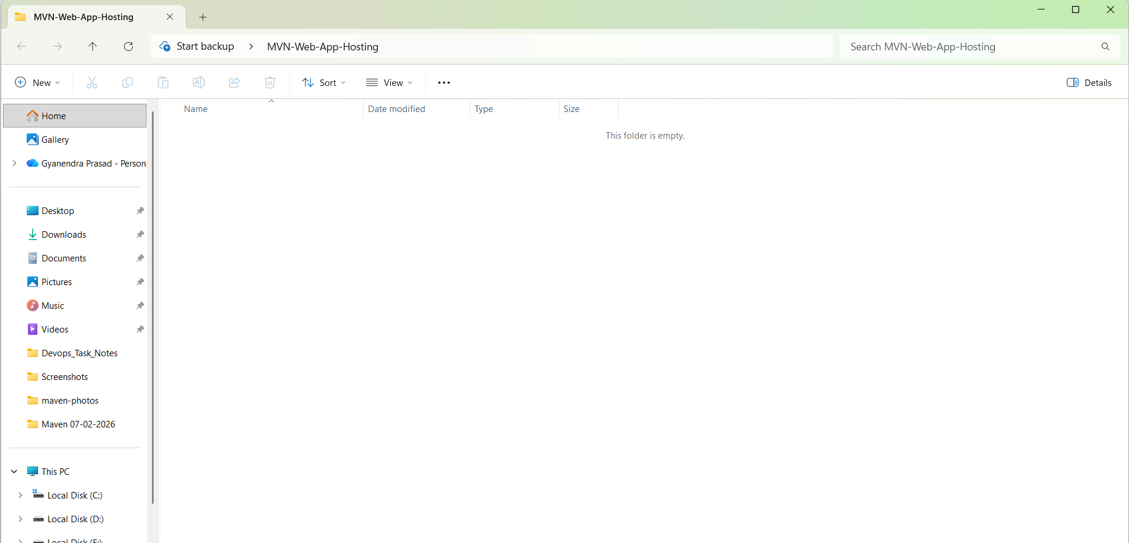

1. Open the VS-Code and open the folder inside.

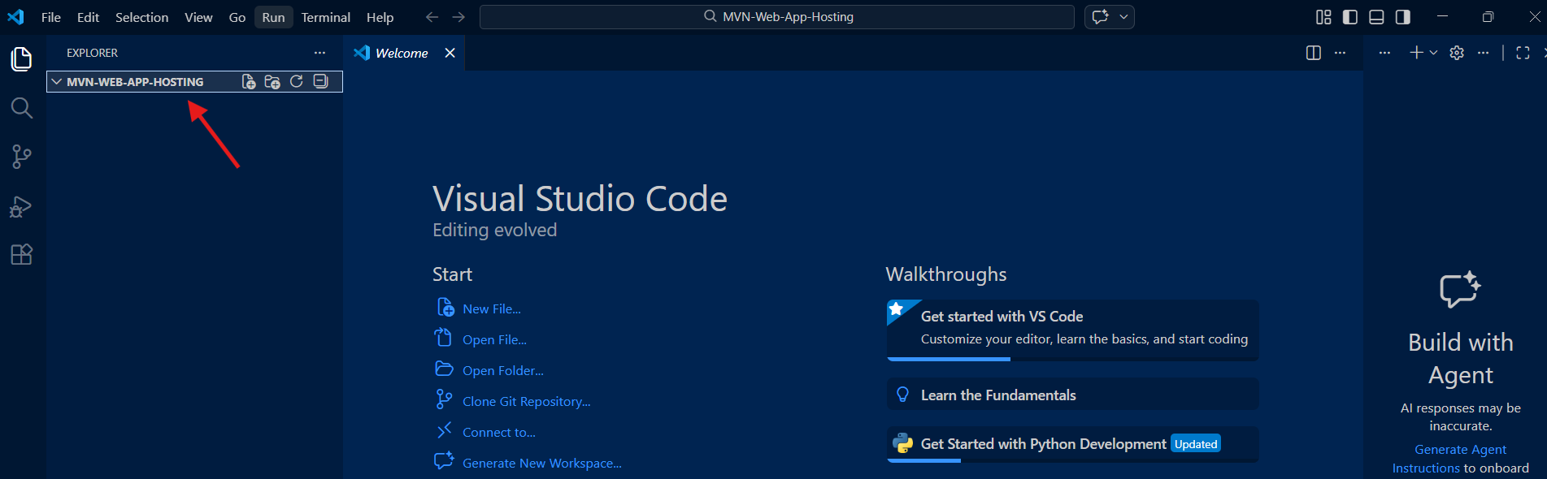

1. I want to create a Web- application so enter this command inside the terminal.

- Now click the toggle pannel and open the terminal inside the vs code.

-First change the terminal from Powershell to Git bash then enter the command.

Syntax:

**mvn archetype:generate -DgroupId=com.mycompany.app -DartifactId=my-webapp -DarchetypeArtifactId=maven-archetype-webapp -DinteractiveMode=false**

ex:

**mvn archetype:generate -DgroupId=com.TCS -DartifactId=Web-app-01 -DarchetypeArtifactId=maven-archetype-quickstart -DarchetypeVersion=1.5 -DinteractiveMode=false**

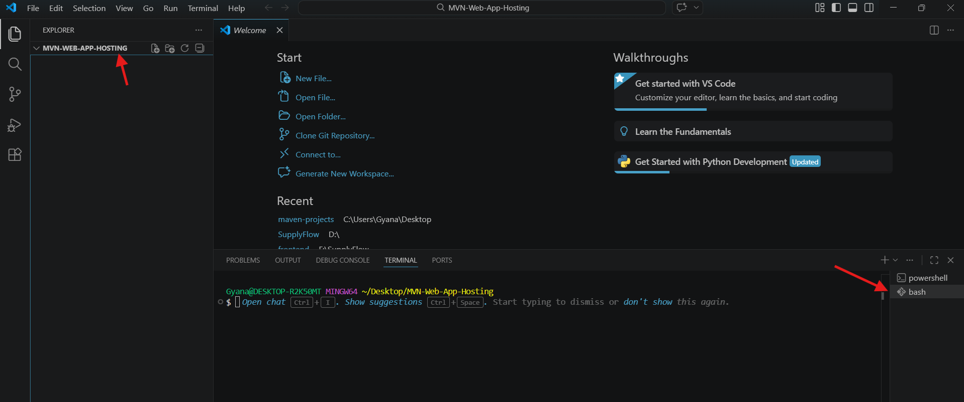

1. After hitting this command it will crate a Web-Application inside the MVN-Web-App-Hosting main project folder.

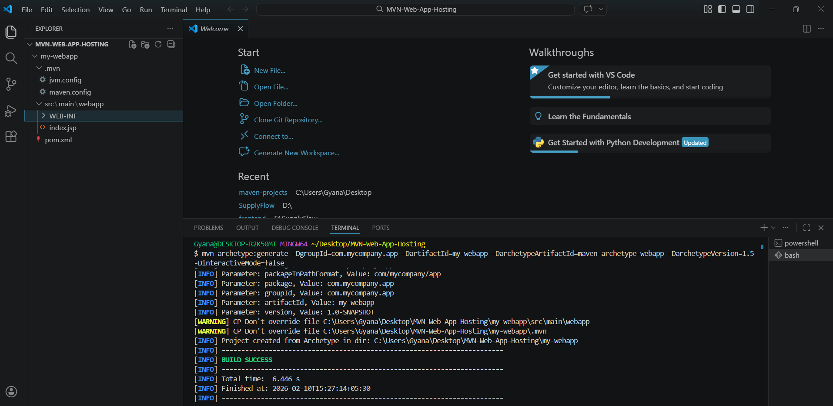

* You can see the project name called my-webapp got created with files and folders.

1. See the folder structure of the project which is nothing but the project structure of java.



1. Now as a devops engineer our work is to execute the Maven goal.
2. Go inside the project folder **my-webapp** because every time the **maven goals** is to execute **inside the project folder.**

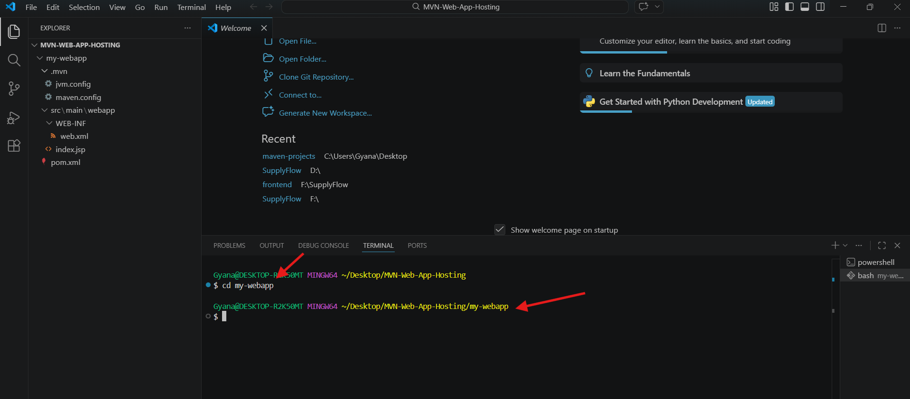

1. We will perform maven goals but before that we have to set up the projects and add codes inside the index.jsp

* Now added the web application code inside the **index.jsp.**

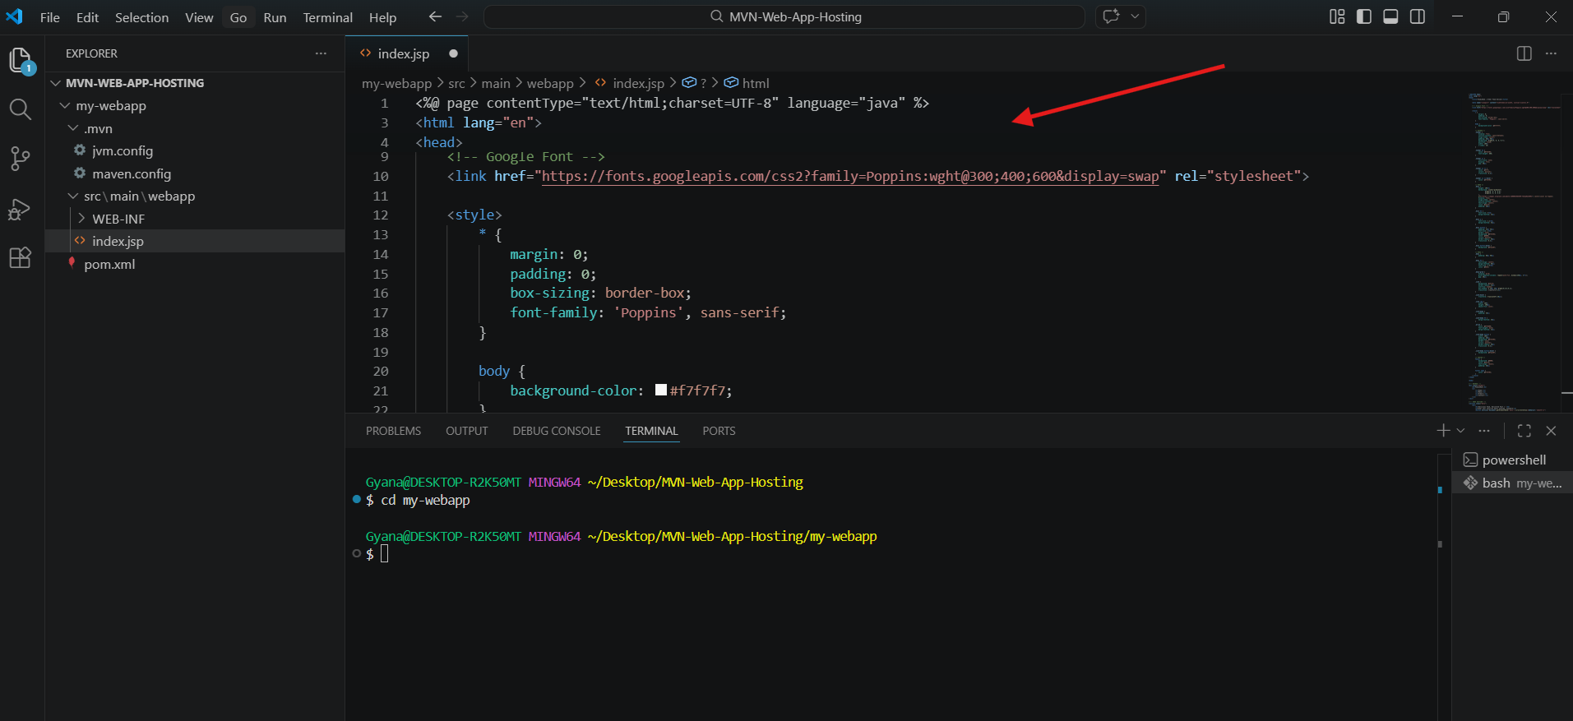

1. Now adding the dependencies in the pom.xml.

**How to add the dependencies in the Project.**

* Visit the web site which is the maven central repository: [**https://mvnrepository.com/**](https://mvnrepository.com/)

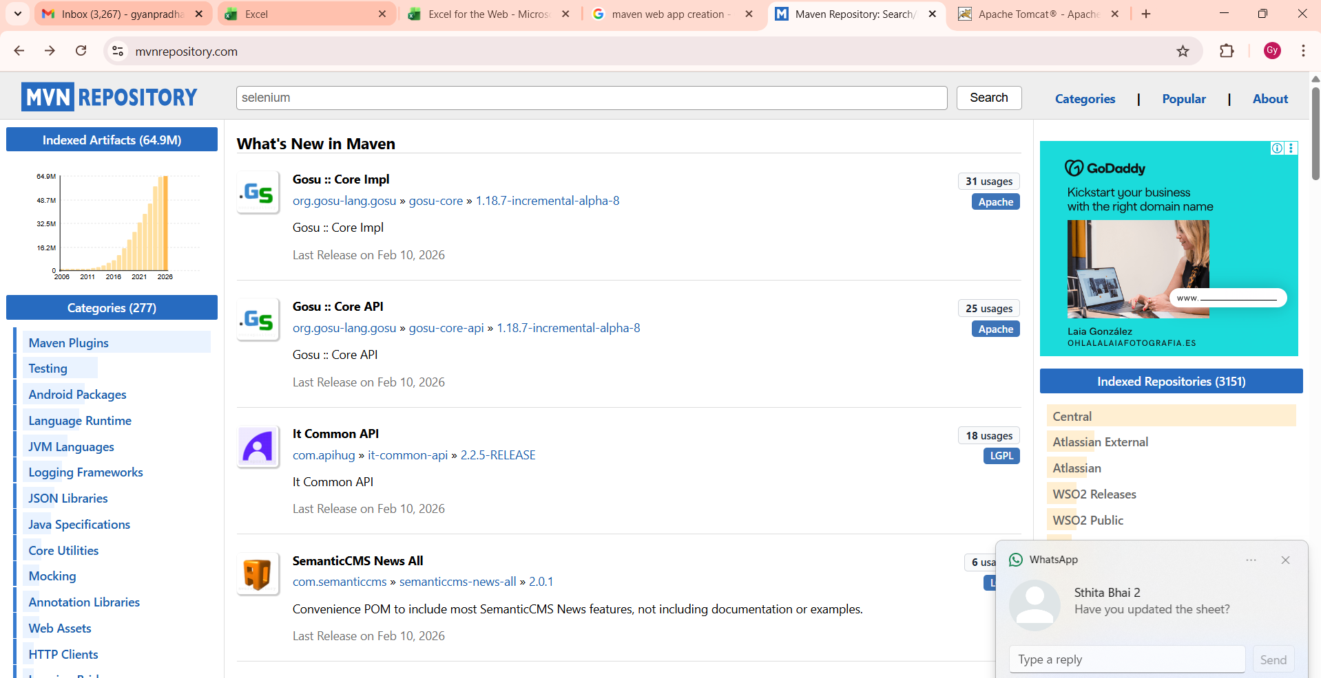

* I am adding the selenium dependencies in the projects that’s why searched the selenium and selected the selenium java : [**https://mvnrepository.com/artifact/org.seleniumhq.selenium/selenium-java**](https://mvnrepository.com/artifact/org.seleniumhq.selenium/selenium-java)

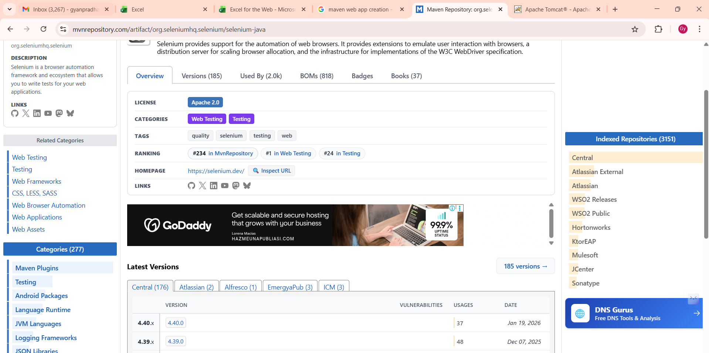

* Selecting the latest version of Selenium Java 4.40.0

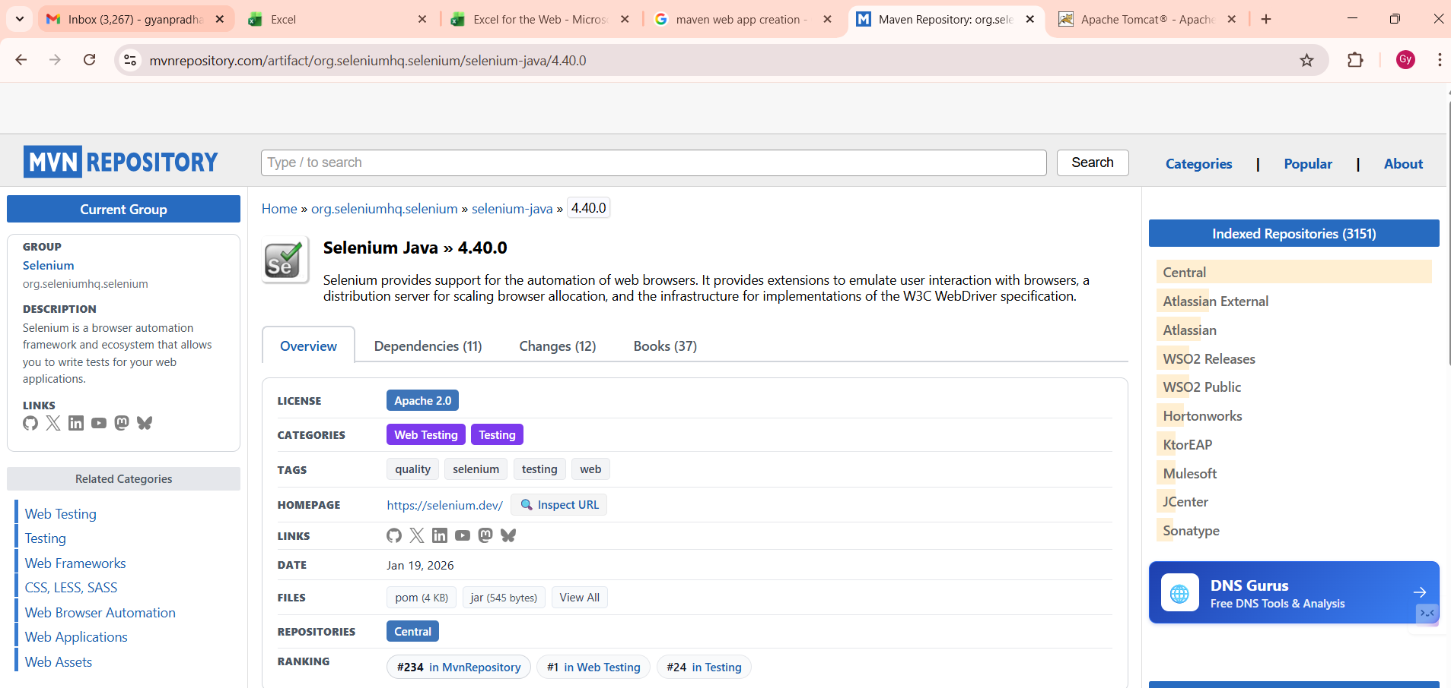

* Then will copy the dependency from here having the scope “compile”

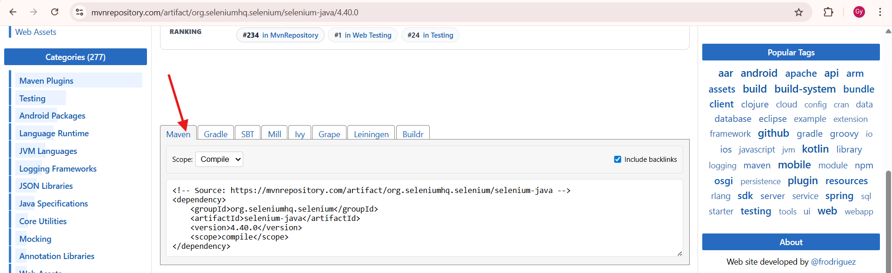

1. Now added the selenium dependency in the **pom.xml** file.
2. Before that it has the dependency having group id **junit.**

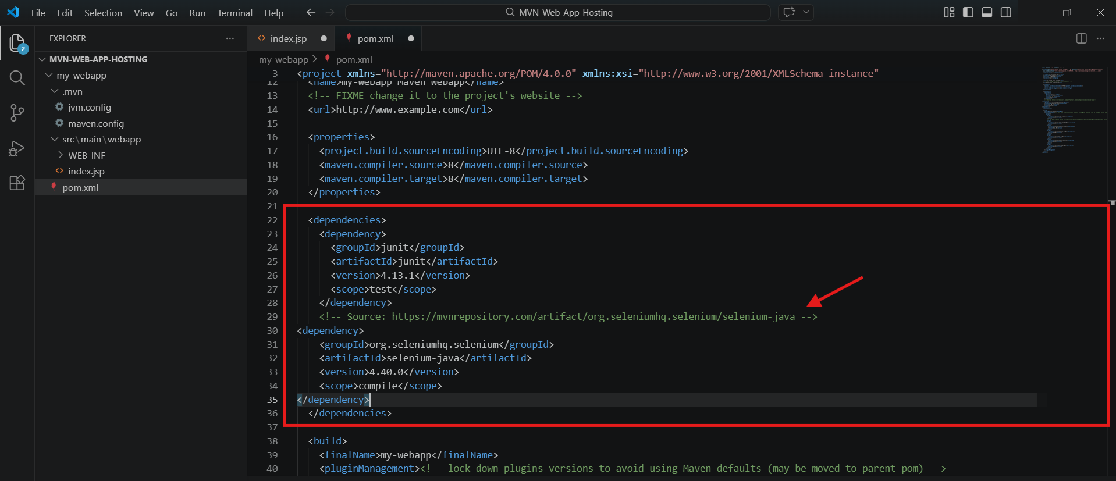

1. Use the command **mvn compile** to compile the java code.

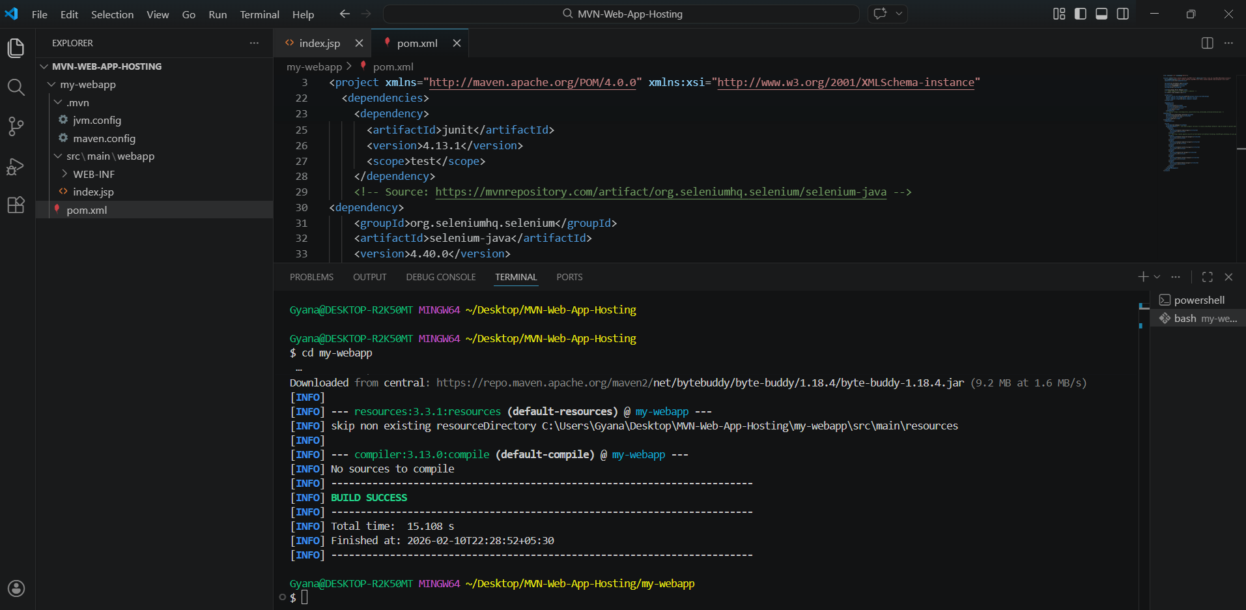

1. After compilation we will test our code.
2. The next maven goal will be : **mvn test** which will test my code that my code is correct or not.
3. If it will show BUILD SUCCESS then or code tested successfully

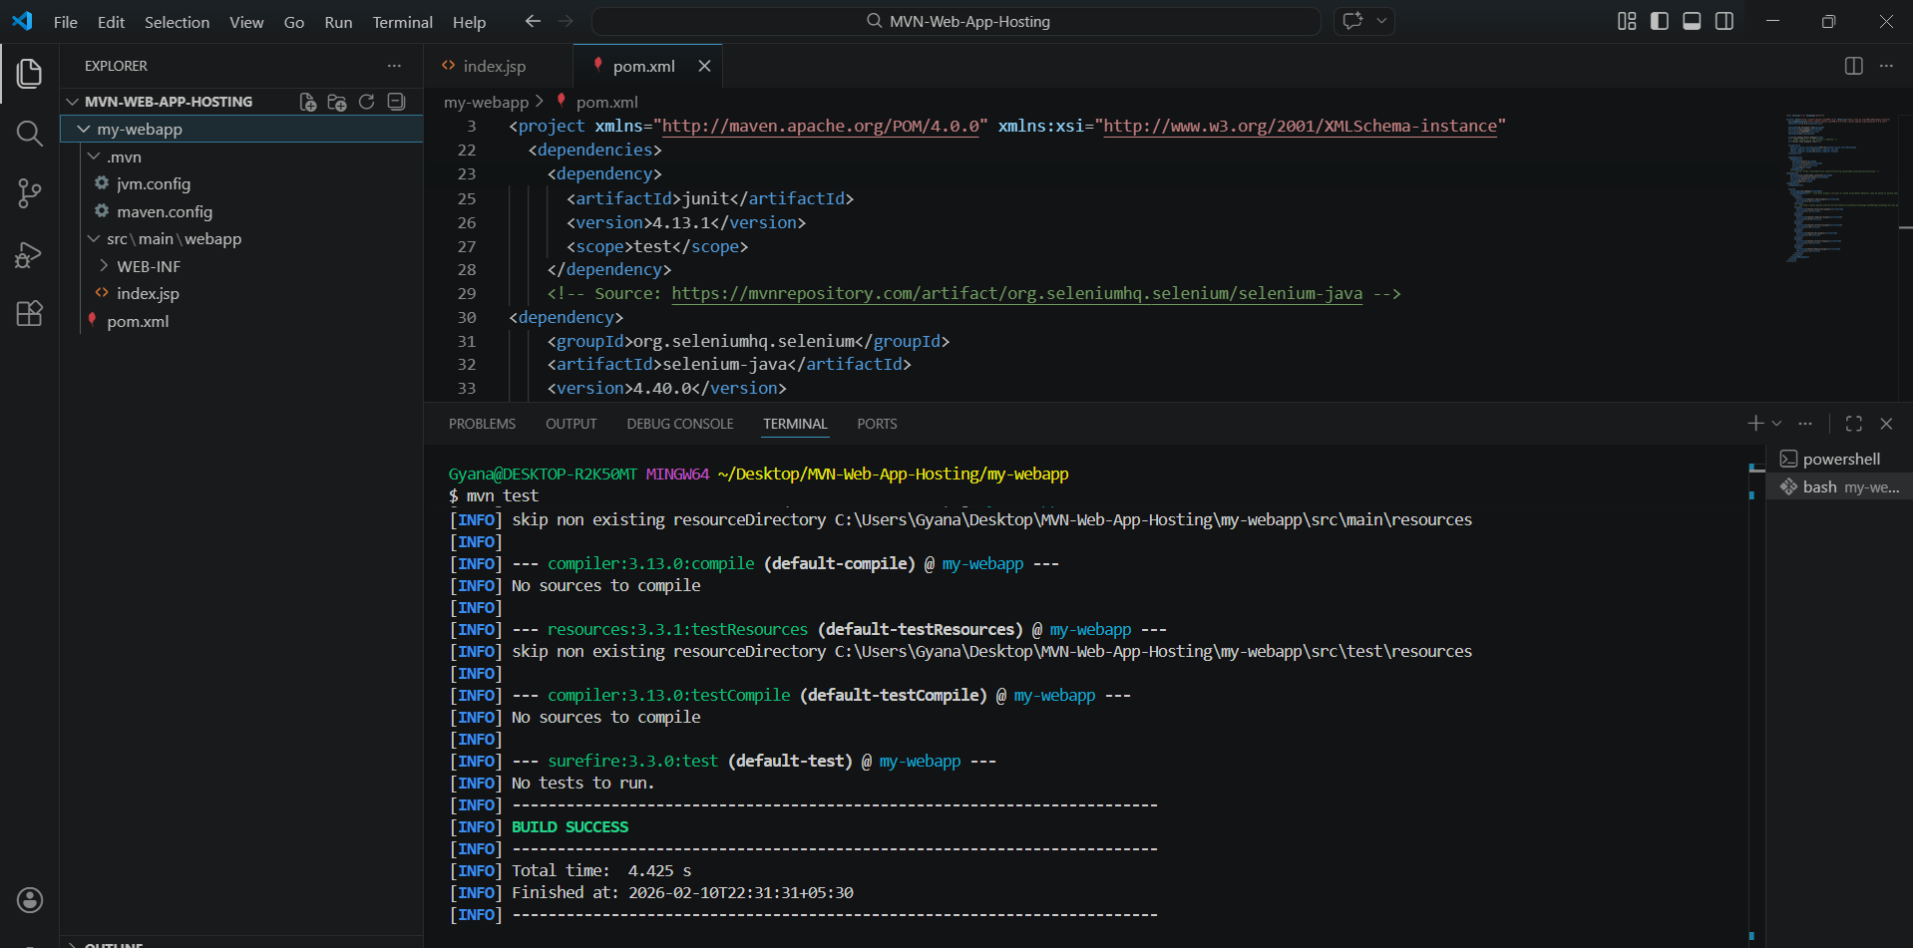

1. Now will package our code using maven goal: **mvn package.**
2. When it appear the **Build success** a target file will be created having the **.war** file.

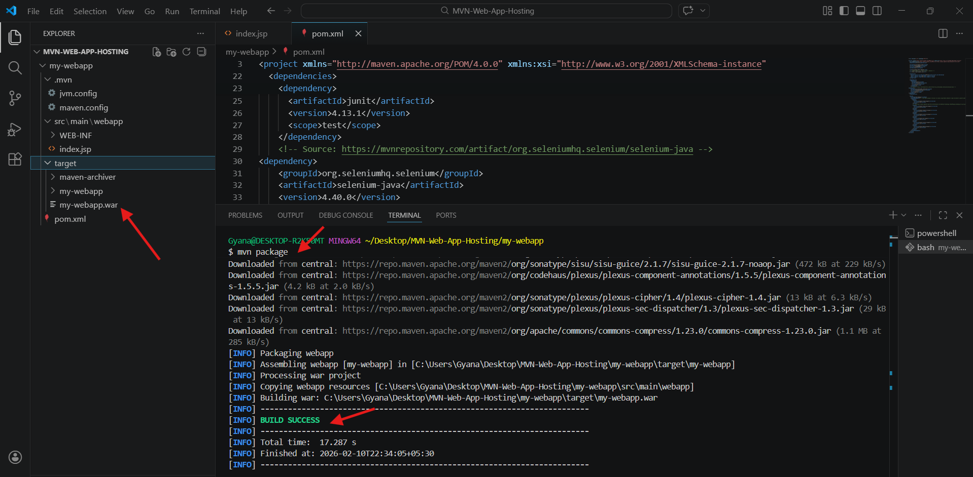

1. All these maven goals we can do in one line by using: **mvn clean compile test package.**

* This command will execute all the goals at a time one after another.
* The **mvn clean** command will delete all the environment and the compile ,test and package command will execute again and a new target folder will create again.

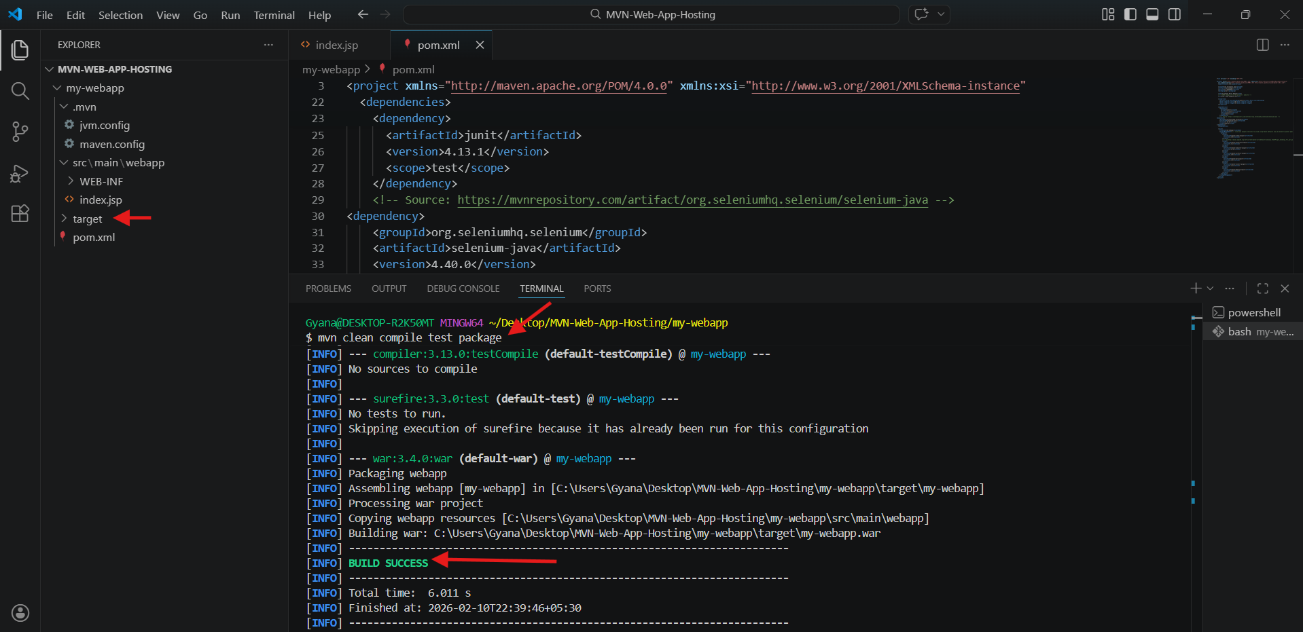

1. Now to host our application through tomcat we need to copy the **.war** file and paste it to the **webapps folder.**

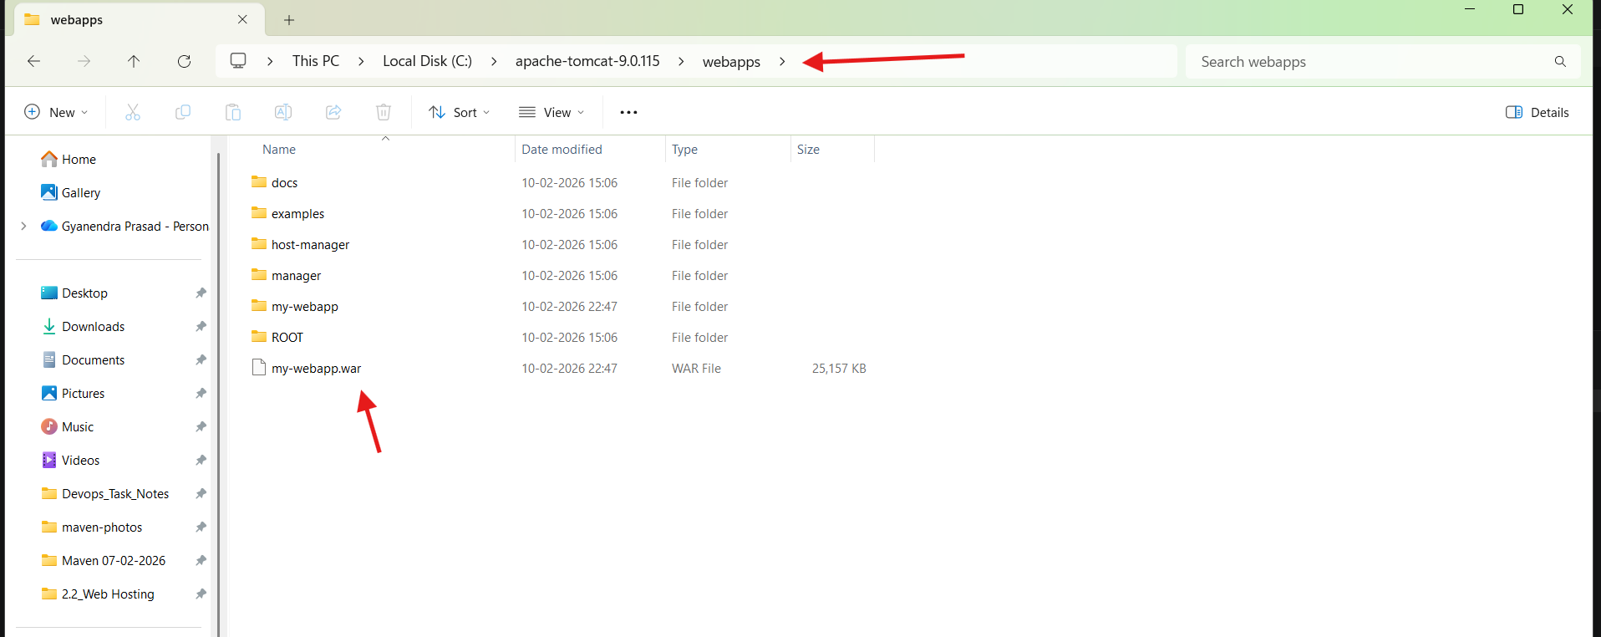

1. Now we have to run the tomcat server.
2. To run the apache tomcat open the **bin** folder inside the **apache-tomcat-9.0.115.**
3. Go inside the **bin** folder there will be **startup batch file** there double click it then tomcat will run.

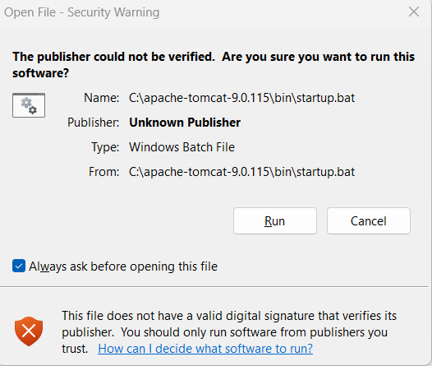

* Click run then tomcat will run.

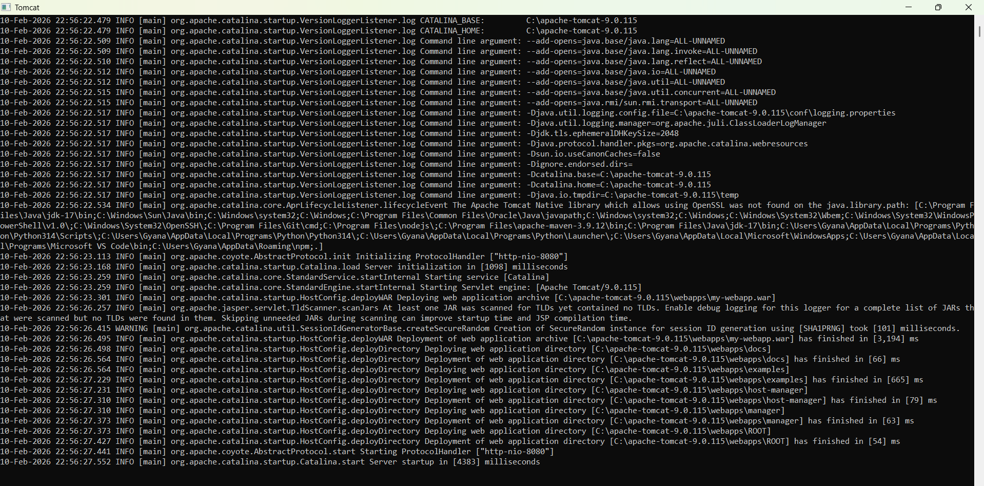

1. Now open browser type: **localhost:8080/your-web-application** to run the web application.
2. I am running my application using : **localhost:8080/my-webapp.**

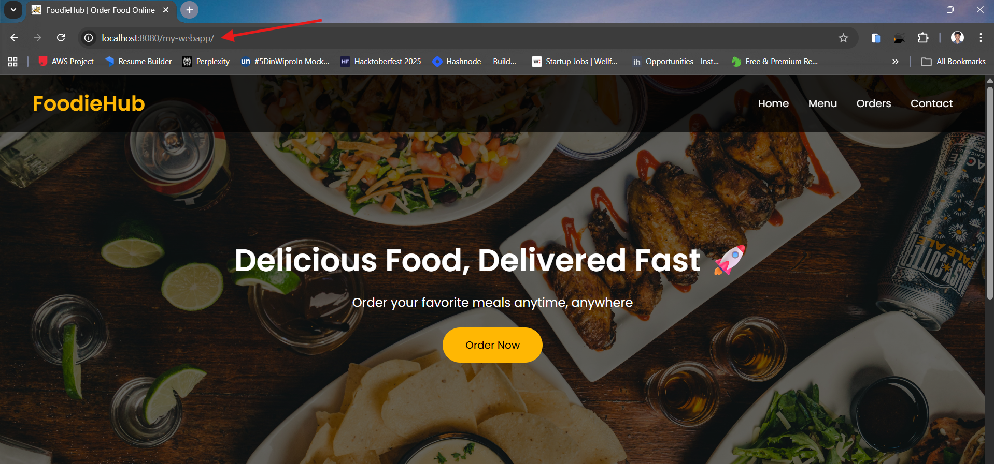

Web application hosted successfully.

* If we terminate the tomcat server then our web application hosting will be closed.
* To close the tomcat open the **bin folder** inside the **apache-tomcat-9.0.115** folder inside the c-drive.
* Look a **shutdown** batch file will be there just double click it and the **tomcat server** will terminate.

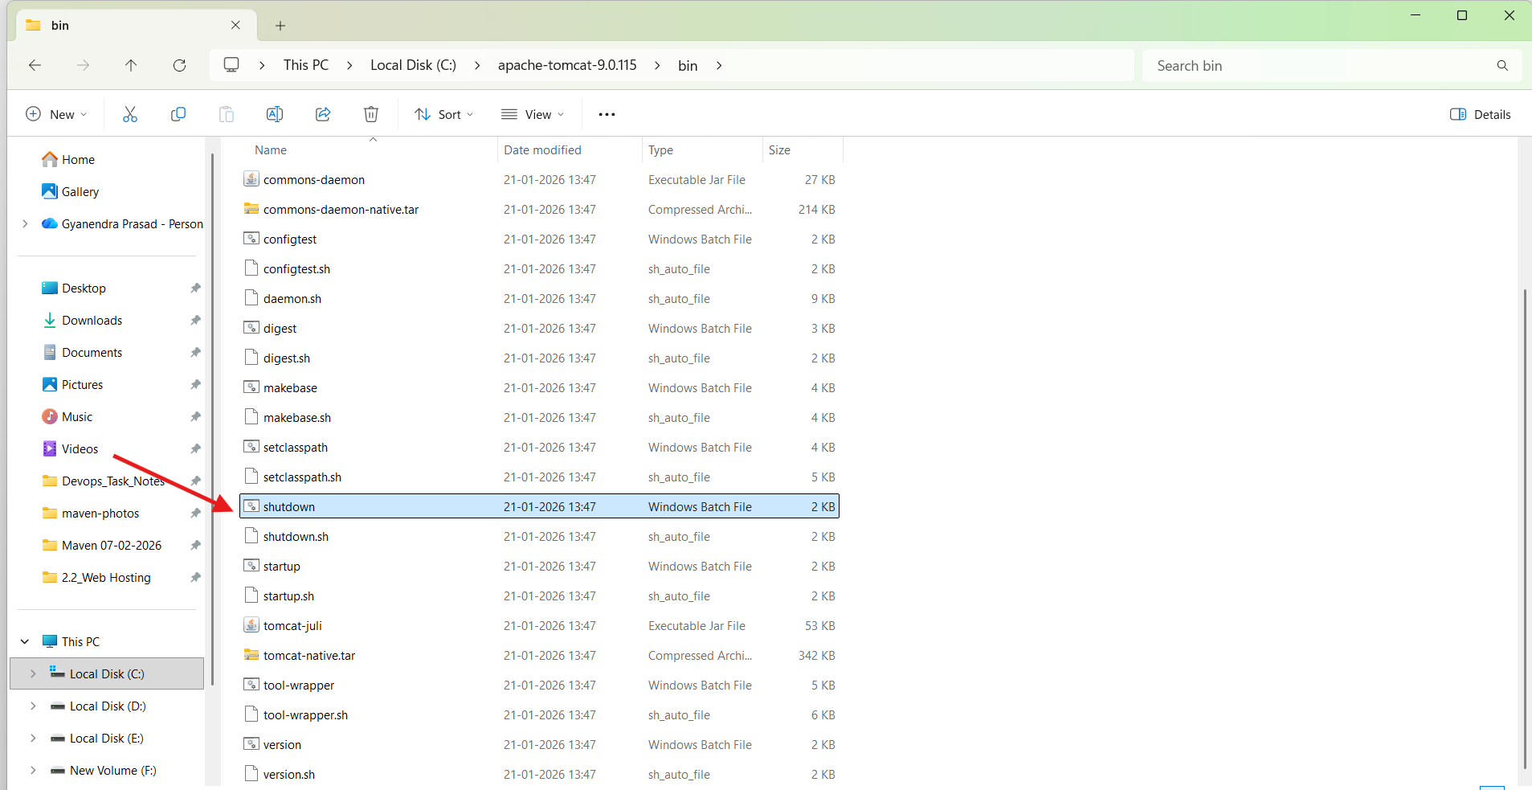

* Web application hosting closed.

